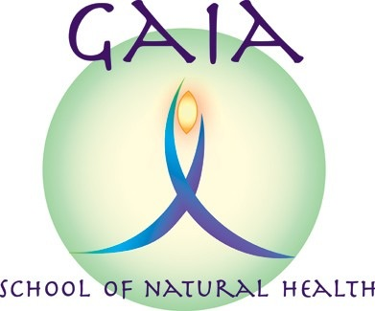
Gaia CrystalReflex Course
Information and Booking Form

Gaia CrystalReflex workshops are designed for qualified reflexologists with little or no prior knowledge of crystals. They also provide a certificated CPD course with which you can gain insurance to safely and effectively utilise crystals within a reflexology session.

What will I learn?

Course Content: Gaia CrystalReflex (Basic): 7 hours

This one day standalone workshop is intended to introduce you to crystals -

- What they are
- How they work
- Safety issues

On completion of this day you will know how to use crystals as an adjunct to your reflexology session. We will cover:

- Choosing and cleansing crystals
- Crystal webs to enhance the energy of the treatment
- Placement of crystals on and around your client
- Use of crystal cards

N.B. This does not include the use of crystals directly on the feet themselves - this is covered in the 2 day course.

Course Content: Gaia CrystalReflex (Facial): 7 hours

Following on from our basic course, we will learn how to use crystals in different forms, within a facial reflexology treatment.

No prior knowledge of facial reflexology is required, but attendees should hold a recognized L3 or L5 reflexology qualification and have attended the Gaia Crystal Reflexology Basic workshop.

At the end of the day, and following successful observation by the course tutor, and completion of a case study and question booklet you will be able to gain insurance to offer the Gaia Crystal Facial Reflexology treatment to your clients.

How do I book?

Please complete and return the slip attached with your non-refundable deposit of £30 to Gaia School of Natural Health. A deposit is non-refundable unless the particular course is cancelled by the Gaia School. The form can be e-mailed back, and the deposit can be paid via BACs.

GAIA CRYSTALREFLEX BOOKING FORM

Please reserve me a place on:
Course | Date(s) | Tick
Gaia CrystalReflex (Basic)  Course fee - £90 | Friday 23rd June 2017,  10.00am – 5.00pm
Gaia CrystalReflex (Basic)  Course fee - £90 | Thursday 28th September 2017,  10.00am – 5.00pm

Please return applications by:
June course: Friday 16th June 2017
September course: Thursday 21st September 2017

Please make a bank transfer for £30 non-refundable deposit to “Gaia School of Natural Health” Sort code: 089299. Account No.: 69643259
Or please make cheques payable to “Gaia School of Natural Health” and send with booking form to 15 Grange Crescent, Childer Thornton, S. Wirral, CH66 5NA.

Name:
E-mail:
Phone No.:
Address:

Date of birth:

Please provide name and phone number of an Emergency Contact:

GAIA CRYSTALREFLEX BOOKING FORM (continued)

Are you trained in other therapies:
Current roles and responsibilities:
Highest level of educational attainment:
Would you like to mention anything else e.g. health issues or learning needs that it would be useful for me to know about?

